2023 - 2024
Team benchmark
Infrastructure Hand-Over
Filip Kolb, Maarten Marx, Lorenzo Miechielsen, Egemen Alkan, Mark Vaikul

Inhoud
1. Project overview 3
2. Github 3
3. Github actions 4
3.1. Overview 4
3.2. Pipeline Jobs 4
3.2.1. SonarQube & Security Scanning (sonarqube job) 4
3.2.2. Steps: 4
3.2.3. Docker Build & Push to ACR (Docker job) 4
3.2.4. Steps: 4
3.3. Manual AI Image Build & Push 4
3.3.1. Steps to Build & Push Manually: 5
3.3.2. Secrets & Configuration 5
4. Azure Portal Configuration 6
4.1. Setting Up Azure Cosmos DB (MongoDB API) 6
4.1.1. Steps to Create Azure Cosmos DB (MongoDB API) 6
5. Deploying Azure Container Apps from ACR 8
5.1. Create Azure Container Apps for API 8
5.2. Create Azure Container Apps for Frontend 10
5.3. Create Azure Container Apps for AI 10
6. Raspberry PI 11
6.1. Overview 11
6.2. Operating System 11
6.3. WiFi and SSH Setup 11
6.4. Remote Access with Tailscale 12
7.1. Using Tailscale for Remote Access 12

Project overview
Frank de pratende Bank is an AI-powered interactive bench developed for Rurant. The project integrates AI, a front-end interface, and a back-end system to create an engaging and informative experience. Frank is designed to help Rurant integrate new ideas in rural environments that users have provided by talking to the bench, answering questions, and getting input from users about the environment in a conversational manner.

Github
https://github.com/FilipKolb/Project4.0

The entire Frank de pratende bank project is located on GitHub. This includes the AI model, front-end, back-end, and infrastructure configurations.

How to Make Changes
If you want to make changes or contribute to the project, follow these steps:
- Fork the Repository
  - Navigate to the GitHub repository.
  - Click the Fork button to create a personal copy of the repository.
- Clone Your Fork
  - Run the following command to clone the repository to your local machine:

git clone https://github.com/FilipKolb/Project4.0.git

- Create a New Branch
  - Use a descriptive branch name for your changes:

git checkout -b “feature-branch-name”
- Make Your Changes
  - Edit the relevant files and commit your changes:

git add .
git commit -m "Describe your changes"
- Push to Your Fork
  - Upload your changes to GitHub:

git push origin feature-branch-name
- Create a Pull Request (PR)
  - Open a Pull Request (PR) from your fork to the main repository.
  - Provide a clear description of the changes and why they are needed.
  - Wait for review and approval before merging.

Github actions

Overview
This GitHub Actions pipeline automates the build, security scanning, and image pushing process for the Frank de pratende bank project. It ensures that every commit to the main and development branches is analyzed for code quality, security vulnerabilities, and successfully built and pushed to Azure Container Registry (ACR).

Pipeline Jobs

SonarQube & Security Scanning (sonarqube job)
This job performs:
Code Quality Analysis using SonarQube.
Static Application Security Testing (SAST) using sast-scan.

Steps:
- Checkout Repository: Fetches the source code.
- SonarQube Scan: Runs a SonarQube analysis using a SONAR_TOKEN stored in GitHub secrets.
- SAST Scan: Analyzes the codebase for security vulnerabilities.

Docker Build & Push to ACR (Docker job)
This job builds the Docker images using Docker Compose and pushes them to Azure Container Registry (ACR).

Steps:
- Login to Azure Container Registry (ACR)
  - Uses GitHub Secrets (ACR_USERNAME & ACR_PASSWORD) for authentication.
- Checkout Repository
  - Retrieves the latest source code.
- Set up Docker Buildx
  - Enables advanced build features for Docker.
- Install Docker Compose
  - Ensures the correct version of Docker Compose is available.
- Build and Push Docker Images
  - Uses docker-compose to build and tag the images.
  - Pushes the images to ACR (project4b1.azurecr.io).

Manual AI Image Build & Push
⚠ Important: The AI image cannot be built using GitHub Actions due to restrictions on required dependencies (e.g., large model files, GPU requirements). Instead, it must be built and pushed manually.

Steps to Build & Push Manually:
- Log in to Azure Container Registry (ACR)
az acr login --name “ACR_name”.azurecr.io
- Build the AI Image Locally
docker build -t “ACR_name”.azurecr.io/ai-image:latest .
- Push the AI Image to ACR
docker push “ACR_name”.azurecr.io/ai-image:latest
- Verify the Image is in ACR
az acr repository list --name “ACR_name” --output table

Secrets & Configuration
The pipeline relies on the following GitHub Secrets for authentication:
- SONAR_TOKEN – Required for SonarQube analysis.
- ACR_USERNAME – ACR service principal username.
- ACR_PASSWORD – ACR service principal password.

Azure Portal Configuration

Setting Up Azure Cosmos DB (MongoDB API)
To store and manage application data, Azure Cosmos DB (MongoDB API) is used.

Steps to Create Azure Cosmos DB (MongoDB API)
- Go to Azure Portal → Search for Cosmos DB.
- Click Create and select Azure Cosmos DB for MongoDB.

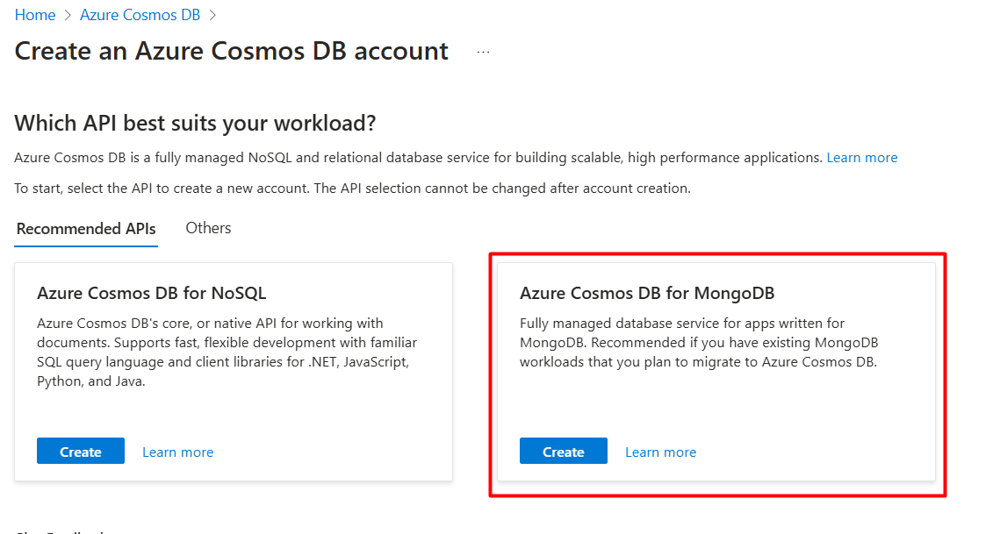

- Choose Request unit (RU) database account

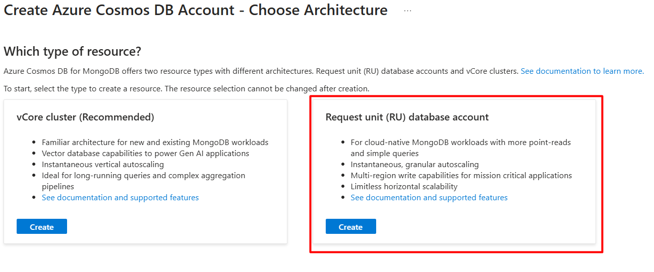

- Set up the database instance:
  - Subscription: Choose your subscription.
  - Resource Group: Create or select an existing one.
  - Account Name: Example: frankdb.
  - Location: Choose a region (e.g., West Europe).
  - Capacity Mode: Choose Provisioned throughput.

- Click Review + Create → Create.

- Connection String:
  - Go to Keys and copy the Primary Connection String.
  - Store it in Azure App Configuration or an environment variable in Azure Container Apps.
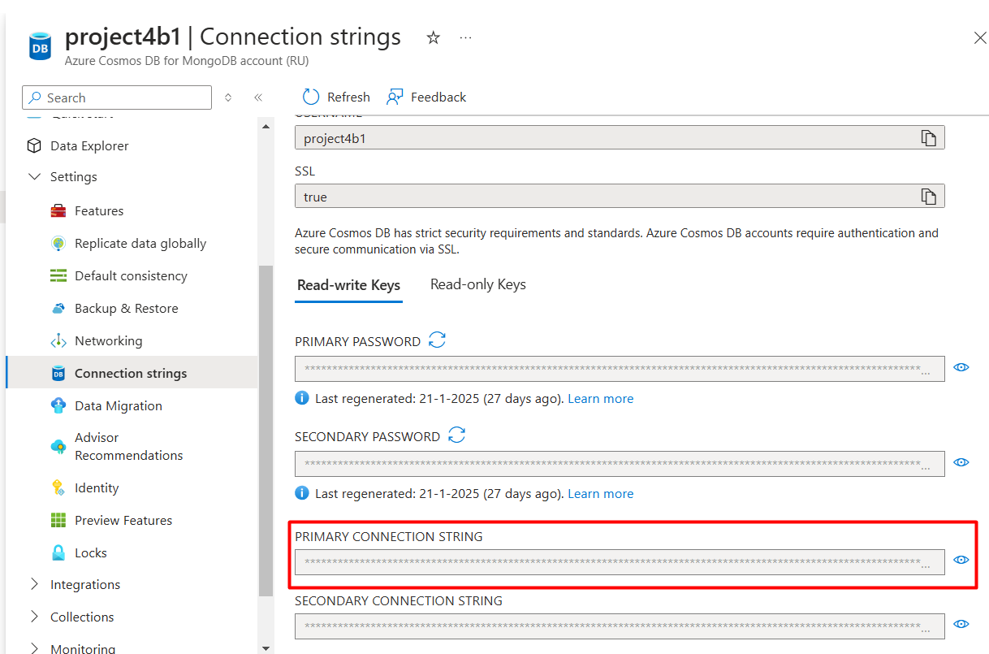

Deploying Azure Container Apps from ACR
To deploy the application using Azure Container Apps, follow these steps:

Create Azure Container Apps for API
- Go to Azure Portal → Search for Container Apps.
- Click Create.
- Configure Basics:
  - Subscription: Select your Azure subscription.
  - Resource Group: Select the same resource group as the resource group you are going to use.
  - Container App Name: Example: api
  - Region: Choose West Europe.
  - Environment: Create a new Azure Container Apps Environment if needed.
- Click Next: Container.

Step 2: Configure Container Settings
- Select Container Source: Choose Azure Container Registry (ACR).
- Registry: Select “ACR_name”.azurecr.io.
- Repository & Tag:
  - Example: api:latest
  - Example: frontend:latest
- CPU & Memory: Set appropriate limits based on the workload.
- Click Next: Ingress.

Step 3: Configure Networking (Ingress)
- Enable Ingress: Yes.
- Traffic settings: Allow public access (for testing) or internal access for private networks.
- Click Next: Environment Variables.

Step 4: Set Environment Variables
Add the required environment variables, including:
- MONGO_CONNECTION_STRING: mongodb://<username>:<password>@”db_name”.mongo.cosmos.azure.com:10255/?ssl=true&retrywrites=false&replicaSet=globaldb&maxIdleTimeMS=120000&appName=@”db_name”@

- LlmApiHost: this should be the URL of the AI container app
example: https://ai.victoriouscliff-d85d07e6.westeurope.azurecontainerapps.io

- Click Review + Create → Create.

Step 5: Enable CORS to the API container app
- Under the settings tab select CORS and under the “Allow Origins” tab you want to add the URL of the frontend container app when it has been created.
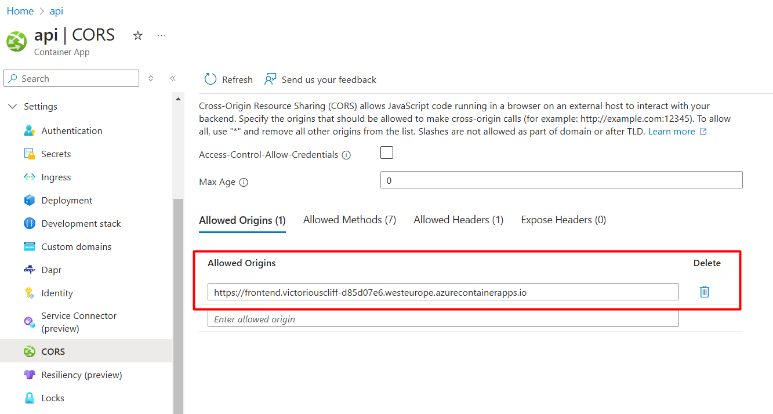

- At the allow headers tab you want to add the HTTP methods we want to allow to the API for example:
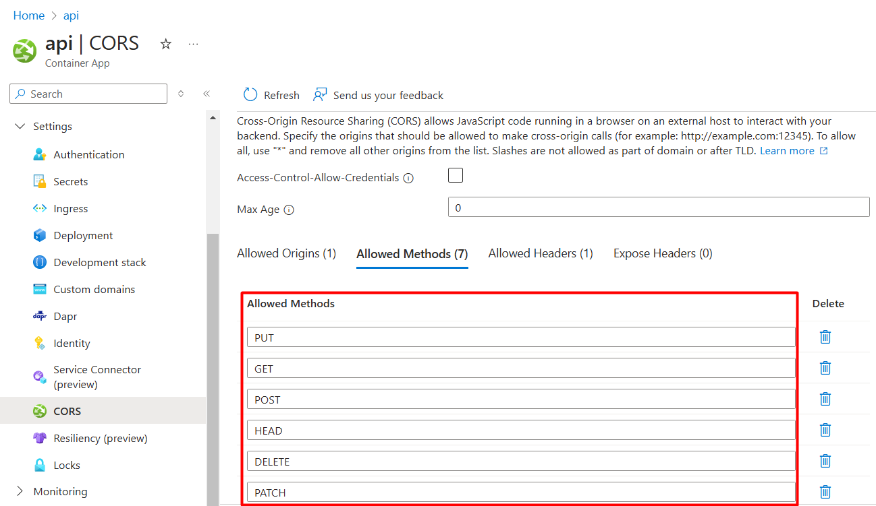

Create Azure Container Apps for Frontend
- Go to Azure Portal → Search for Container Apps.
- Click Create.
- Configure Basics:
  - Subscription: Select your Azure subscription.
  - Resource Group: Select the same resource group as the resource group you are going to use.
  - Container App Name: Example: frontend
  - Region: Choose West Europe.
  - Environment: Create a new Azure Container Apps Environment if needed.
- Click Next: Container.

Step 2: Configure Container Settings
- Select Container Source: Choose Azure Container Registry (ACR).
- Registry: Select “ACR_name”.azurecr.io.
- Repository & Tag:
  - Example: api:latest
  - Example: frontend:latest
- CPU & Memory: Set appropriate limits based on the workload.
- Click Next: Ingress.

Step 3: Configure Networking (Ingress)
- Enable Ingress: Yes.
- Traffic settings: Allow public access (for testing) or internal access for private networks.
- Click Review + Create → Create.

Create Azure Container Apps for AI
- Go to Azure Portal → Search for Container Apps.
- Click Create.
- Configure Basics:
  - Subscription: Select your Azure subscription.
  - Resource Group: Select the same resource group as the resource group you are going to use.
  - Container App Name: Example: ai
  - Region: Choose West Europe.
  - Environment: Create a new Azure Container Apps Environment if needed.
- Click Next: Container.

Step 2: Configure Container Settings
- Select Container Source: Choose Azure Container Registry (ACR).
- Registry: Select “ACR_name”.azurecr.io.
- Repository & Tag:
  - Example: api:latest
  - Example: frontend:latest
- CPU & Memory: Set appropriate limits based on the workload.
- Click Next: Ingress.

Step 3: Configure Networking (Ingress)
- Enable Ingress: Yes.
- Traffic settings: Allow public access (for testing) or internal access for private networks.
- Click Next: Environment Variables.

Step 4: Set Environment Variables
Add the required environment variables, including:
- GEMINI_API_KEY: this should be the API KEY that you get from Gemini.

- BENCH_API_URL: this should be the URL of the API container app
example: https://api.victoriouscliff-d85d07e6.westeurope.azurecontainerapps.io

- Click Review + Create → Create.

Raspberry PI

Overview
This Raspberry Pi 5 is running Raspberry Pi OS Lite and is configured to connect to a WiFi network. Additionally, it has Tailscale VPN installed, allowing secure remote access via a Tailnet.

Operating System
The Raspberry Pi runs Raspberry Pi OS Lite, a minimal Debian-based operating system optimized for headless setups.

Installation Steps:
- Download Raspberry Pi OS Lite from the official Raspberry Pi website.
- Flash the OS onto an SD card using Raspberry Pi Imager or Balena Etcher.
- Configure the system for SSH and WiFi (see below).

WiFi and SSH Setup
After booting up your Raspberry Pi 5 with Raspberry Pi OS Lite, you can configure WiFi and enable SSH using an interactive setup wizard.
Step 1: Access the Raspberry Pi Configuration Wizard
- Boot up the Raspberry Pi and log in using the default credentials:
  - Username: pi
  - Password: raspberry (You will be prompted to change this)
- Start the Raspberry Pi configuration wizard by running:

sudo raspi-config

Step 2: Enable WiFi
- In the raspi-config menu, navigate to:
1 System Options -> S1 Wireless LAN
- Enter your WiFi SSID and password when prompted.
- Select your country for the correct wireless settings.

Step 3: Enable SSH
- In raspi-config, go to:
3 Interface Options -> P2 SSH
- Select Enable to turn on SSH access.

Step 4: Apply Changes and Reboot
Once WiFi and SSH are configured, exit raspi-config and reboot the Raspberry Pi to apply the settings:
sudo reboot
Now, you can connect to your Raspberry Pi via SSH using:
ssh pi@<raspberry-pi-ip>
(To find the IP, use hostname -I on the Raspberry Pi.)

Remote Access with Tailscale
Tailscale is used to allow secure remote access to the Raspberry Pi via a Tailnet.
- Installation Steps:
- Update the system:
sudo apt update && sudo apt upgrade -y
- Install Tailscale:
curl -fsSL https://tailscale.com/install.sh | sh
- Start and authenticate Tailscale:
sudo tailscale up
This will generate an authentication URL. Open it in a browser to authorize the device.
- To check the connection status, run:
tailscale status

Using Tailscale for Remote Access
- Once authenticated, the Raspberry Pi will be part of the Tailnet.
- You can now SSH into the Raspberry Pi using its Tailscale IP:
ssh pi@100.x.x.x

For additional information be sure to consult this documentation https://fleetstack.io/blog/install-tailscale-raspberry-pi
a

